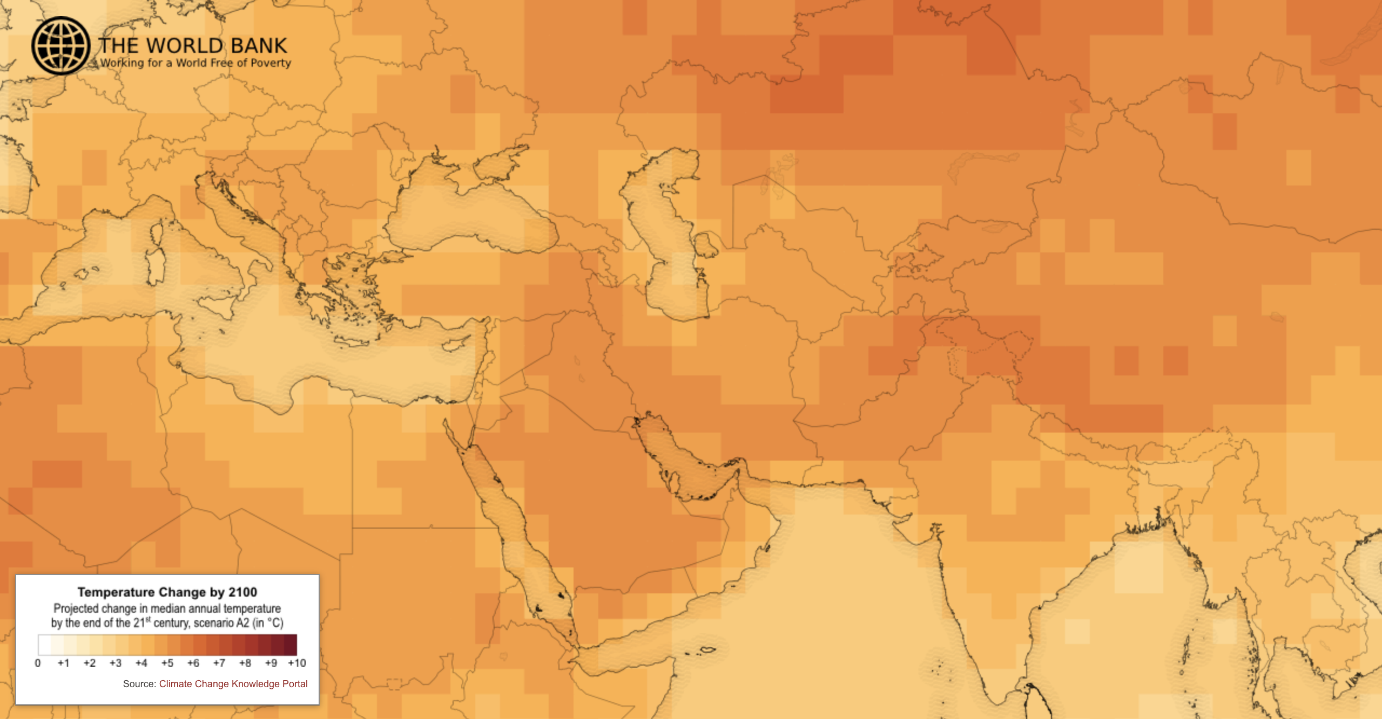

Projected temperature increases by 2100, relative to late twentieth-century averages, according to a middle emissions scenario.

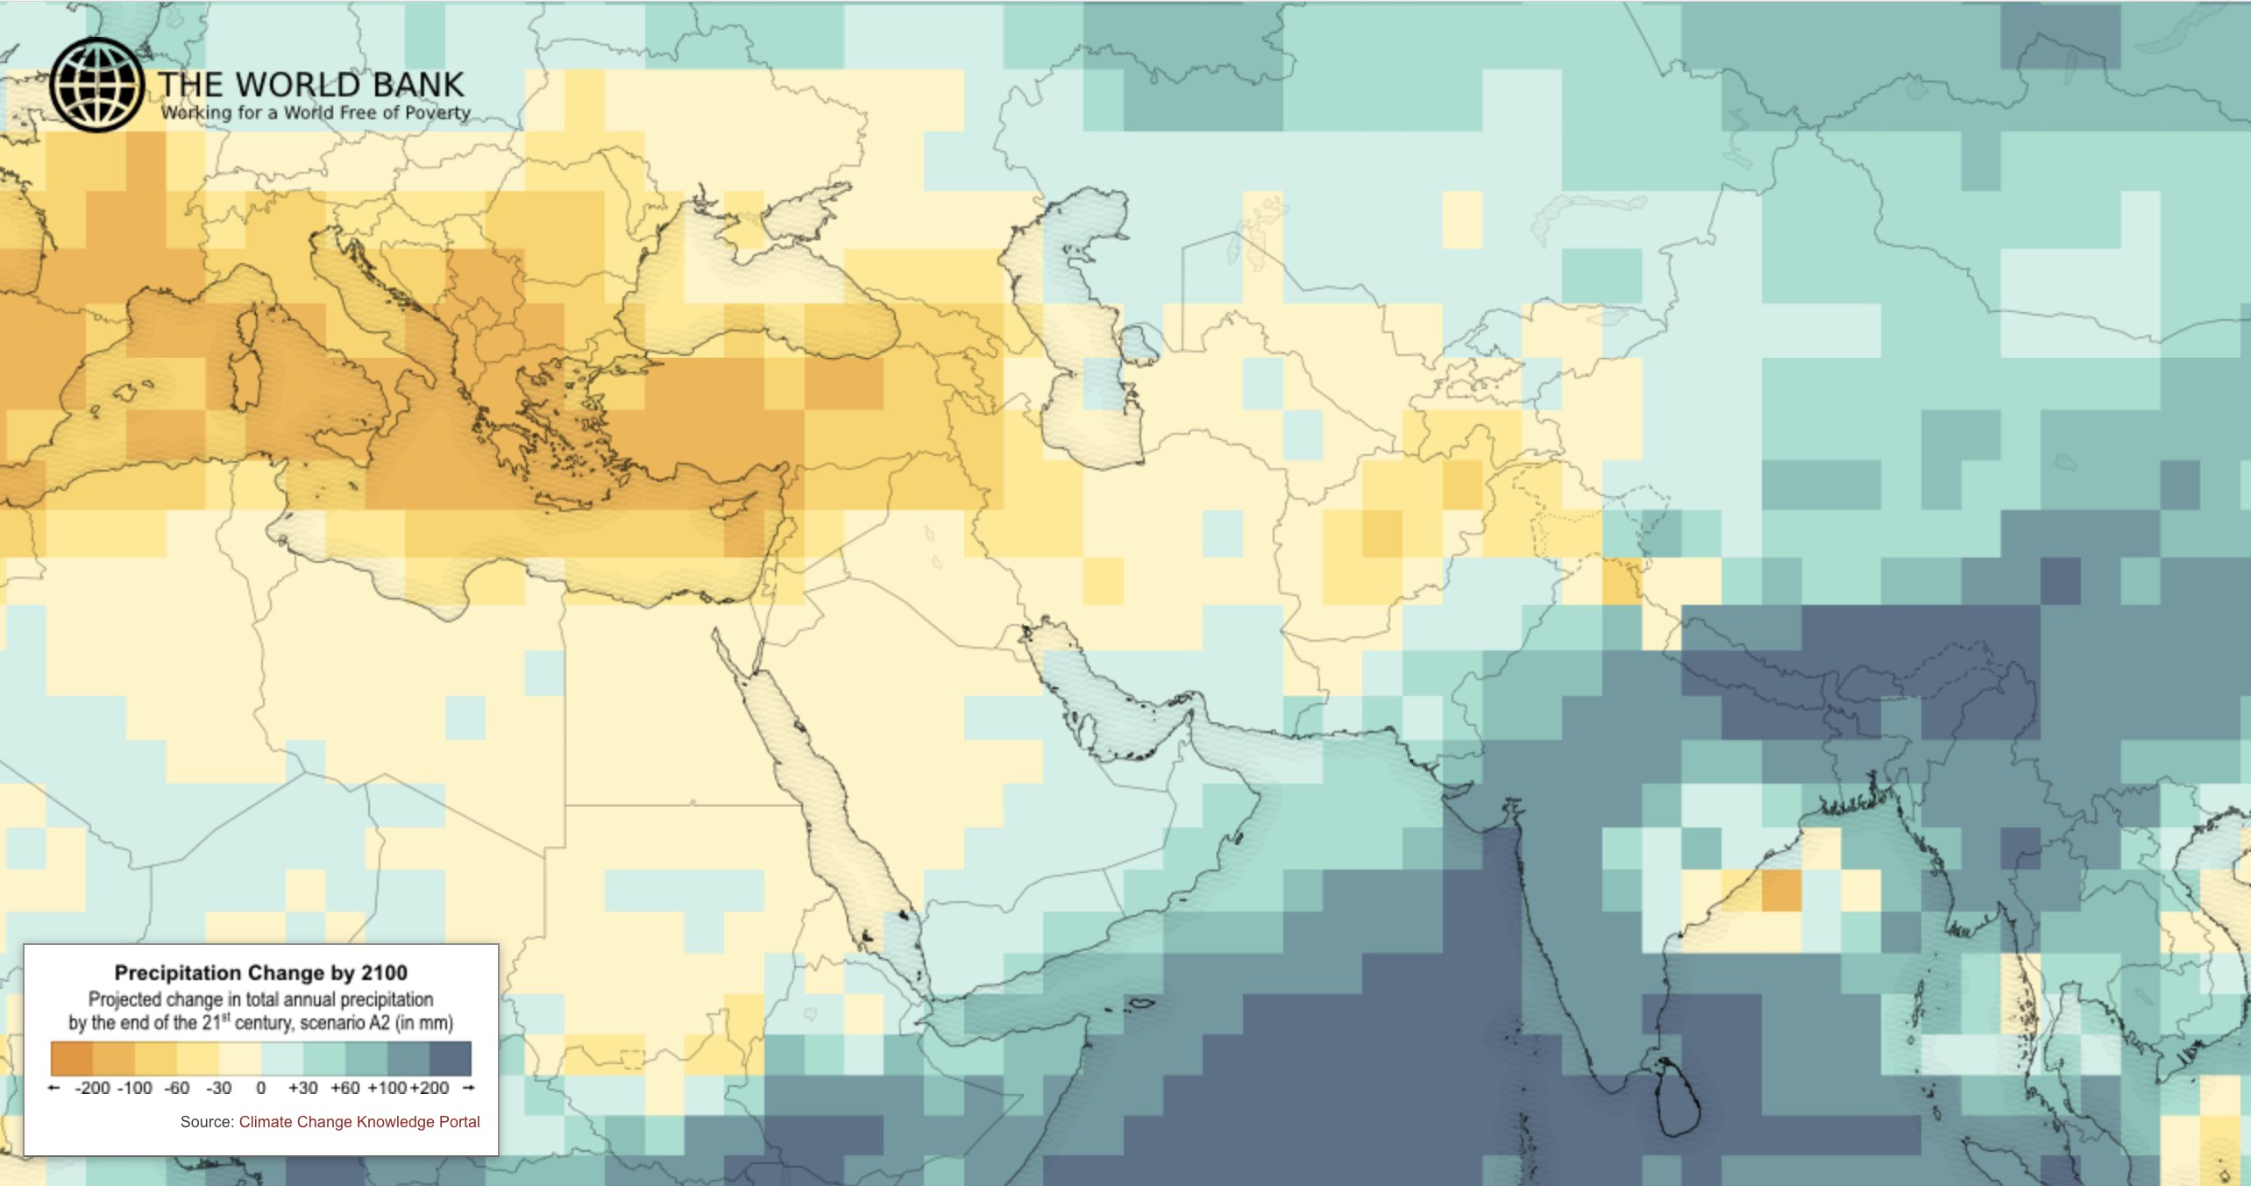

Projected precipitation changes by 2100, relative to late twentieth-century averages, according to the same emissions scenario.

